Out of the 1 billion Facebook accounts 250,000 of them consist of fake accounts. These accounts are made by people who preserve their identity and speak their mind. They’re afraid to reveal who they really are for the fear that they won’t be accepted. Facebook isn’t the only place people seek acceptance through anonymous profiles. All of social media is a domain with people who seek other’s approval. This approval may be through comments on a video on YouTube or through posting memes in Tumblr. Social media has this ability to change how people think. This large group of people associate with one another without truly ever knowing each other, but want each other’s acceptance to their views and ideas. Social media has created a culture through which people change themselves in order to conform to the approving opinions of the majority of the people that participate in it.

People who participate in social media are driven by a personal currency that is given to them through likes, up votes, shares, or favorites. They rely on these little icons to provide them their self-worth through their actions in social media. All those positive comments and likes seem to determine people’s means of self-appreciation. Someone who posts a selfie on Facebook gets overjoyed by all the attention and likes. However, when someone else tries to follow their example but fails to get that amount of attention, they sulk in despair. Their despair leads them to change themselves and be someone they aren’t. The digital currency of likes has manipulated people to always feel doubtful if they don’t receive the attention others do. Nonetheless, the more likes someone has on their Facebook posts, the more their confidence rises by each click. It has become an obsession. An obsession where people begin doing and saying whatever they can to get this appraisal from their peers in social media. Some people begin to leave harsh comments directed towards unsuspecting people for more attention. This digital currency validates some people’s self-appreciation as others may agree with them in their views. These views, however, aren’t always the ones someone may support themselves.

Sometimes, though, people hate on others just because it’s popular to hate. One place this happens often is on YouTube. These commenters tend to forget that the person on their screen isn’t just a combination of pixels and continue with their harsh comments for their own satisfaction and their greed for this digital currency of likes. The commenters continue with these immoral actions as they see that attempts by others were proven to be successful. One example of this was with the harsh comments that began appearing on Rebecca Black’s video on YouTube. When turtle shell wrote their insulting comment of Rebecca Black, they knew it was a trend at the time and would receive likes for their ominous comment. At the time the community deemed it appropriate to hate Rebecca Black. As seen in the rating of the comment, Turtle Shell has received over 100 likes. Others didn’t correct him for his cruel comment but approved of it. Later people followed this example and let the comments get worse by each scroll. People kept commenting with these negative remarks since one person has already succeeded in getting the approval of the community with their comment.

Social media is a powerful tool that allows a large population to collaborate in numerous events. Such a collaboration has united people sometimes for the better and sometimes for the worse. The people of social media post what they think will get them attention. The power of social media dictates what is normal among its users. It dictates what everyone else can say to get the attention of others. Social media creates a new framework for what is normal in each instance of an event. The digital currency of social media manipulates people into taking part in deeds that don’t seem so normal. Their judgement is unclear and affected by the rest of the community as well. People begin doing unreasonable things to satisfy their need for attention on social media. People change their views and ideas to conform to the majority and gather all the likes and appraisal of the community. When a particular comment gets a high rating on a video it sets an example for other people to follow. Conformity in social media causes people to deviate from their usual selves as they indulge in the culture of social media.

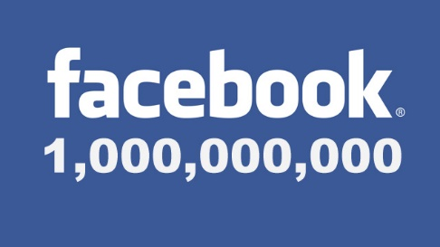

<http://www.netinspire.co.uk/1-billion-people-used-facebook-in-1-day/>



<http://www.compsmag.com/how-to-stay-anonymous-online/>



http://www.rawstory.com/2015/04/google-play-store-dumps-app-that-made-it-easier-to-stalk-and-harass-gun-safety-advocates/



<http://media.scmagazine.com/images/2013/11/18/1863061360_496499.jpg?format=jpg&zoom=1&quality=70&anchor=middlecenter&width=320&mode=pad>



<http://cdni.wired.co.uk/620x413/a_c/anonymous-stock.jpg>



<http://i-1.prod-cdn.webapps.microsoft.com/r/image/view/-/5554368/highRes/1/-/tumblr-png.png>



http://growtraffic.com/blog/wp-content/uploads/2014/12/how-to-get-reddit-traffic.jpg



<http://customtricks.com/wp-content/uploads/2013/10/Facebook-Like.jpg>

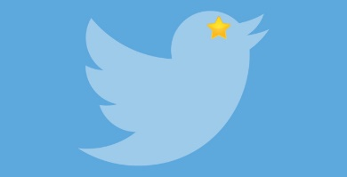https://tctechcrunch2011.files.wordpress.com/2015/11/twitter-star.jpg?w=680&h=348



<https://patricialeslieauthor.files.wordpress.com/2014/06/soc-med-logos.jpg>

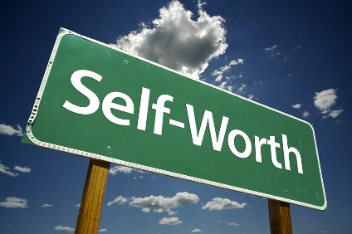

<http://www.psychalive.org/wp-content/uploads/2014/05/self-worth.jpg>

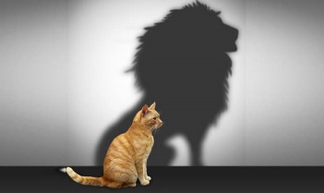

<http://julliengordon.com/wp-content/uploads/2015/05/self_esteem_lion.jpg>



<http://www.soulreflectionscoaching.com/iloveme.jpg>



<https://thesituationist.files.wordpress.com/2007/10/hate-image.jpg>

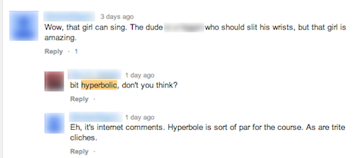

<http://www.socialmediaexaminer.com/wp-content/uploads/2014/04/ms-negative-smmw-video-comment.png>



<http://rack.3.mshcdn.com/media/ZgkyMDEzLzAyLzIwL2YyL2J1bGx5aW5nLjhiNjEzLnBuZwpwCXRodW1iCTk1MHg1MzQjCmUJanBn/0496e78c/ebc/bullying.jpg>

 <https://www.youtube.com/watch?v=kfVsfOSbJY0>



https://www.youtube.com/watch?v=kfVsfOSbJY0